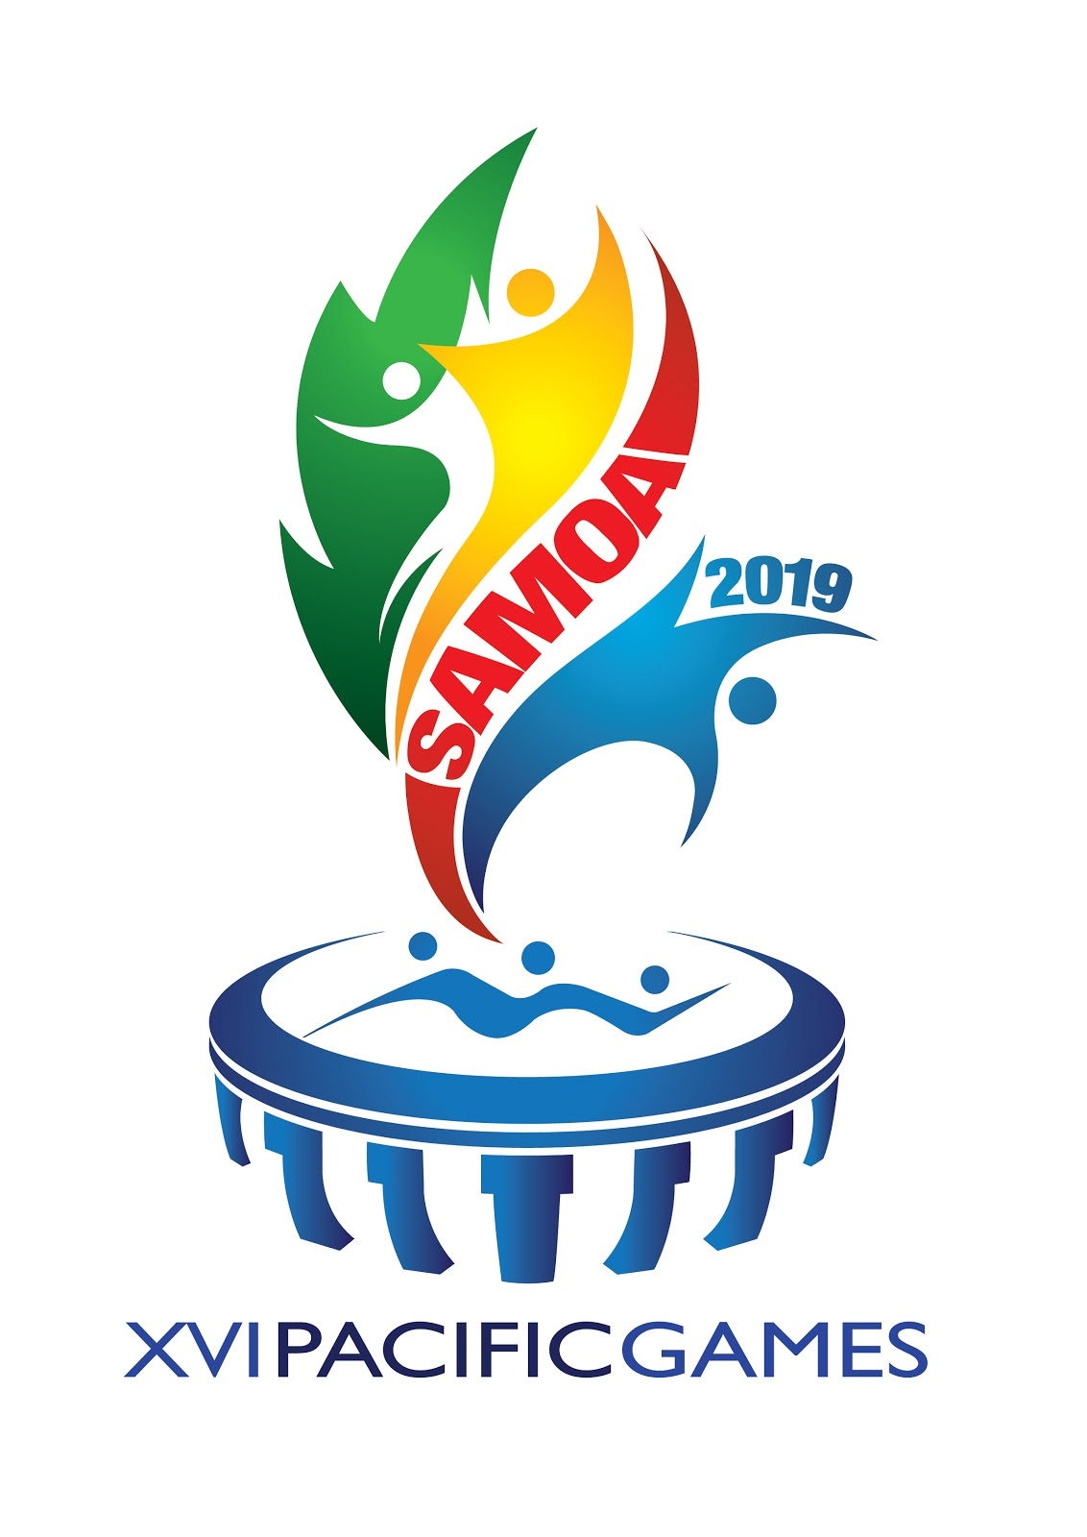
PACIFIC GAMES SQUASH - SAMOA 2019
WOMEN’S TEAM EVENT
RESULTS
DAY 4 – Thursday 11 July – FINALS

BRONZE MEDAL PLAYOFF – 9.30am

Team |  | FIJI |  |  |  | Team | PAPUA NEW GUINEA
Player |  |  | Score | Game Score |  | Player |  | Score | Game Score
1 | Alison MU |  | 11-5,11-6,11-2 | 3-0 |  | Nicole GIBBS |  | 5-11,6-11,2-11 | 0-3
2 | Janice CHAN |  | 4-11,11-6,4-11,11-8,11-3 | 3-3 |  | Eli WEBB |  | 11-4,6-11,11-4,8-11,3-11 | 2-3
3 | Makiti SOKIDI |  | 10-12,8-11,7-11 | 0-3 |  | Olding SUARI |  | 12-10,11-8,11-7 | 3-0
 | TOTAL GAME SCORE |  |  | 2 |  | TOTAL GAME SCORE |  |  | 1

GOLD MEDAL PLAYOFF – 2.30pm

Team |  | NEW CALEDONIA |  |  | N | Team | SAMOA
Player |  |  | Score | Games |  | Player |  | Score | Game Score
1 | Kareen MARECHALLE |  | 11-2,11-8,12-10 | 3-0 |  | Opera Monzeri |  | 2-11,8-11,10-12 | 0-3
2 | Caroline QUACH |  | 5-11,11-2,11-9,11-3 | 3-1 |  | Lupe KAPISI |  | 11-5,2-11,9-11,3-11 | 1-3
3 | Vanessa QUACH |  | 11-4,11-4,11-1 | 3-0 |  | Samantha MARFLEET-MANU |  | 4-11,4-11,1-11 | 0-3
 | TOTAL GAME SCORE |  |  | 3 |  | TOTAL GAME SCORE |  |  | 0

FINAL PLACINGS

GOLD MEDAL | SILVER MEDAL | BRONZE MEDAL
NEW CALEDONIA | SAMOA | FIJI

