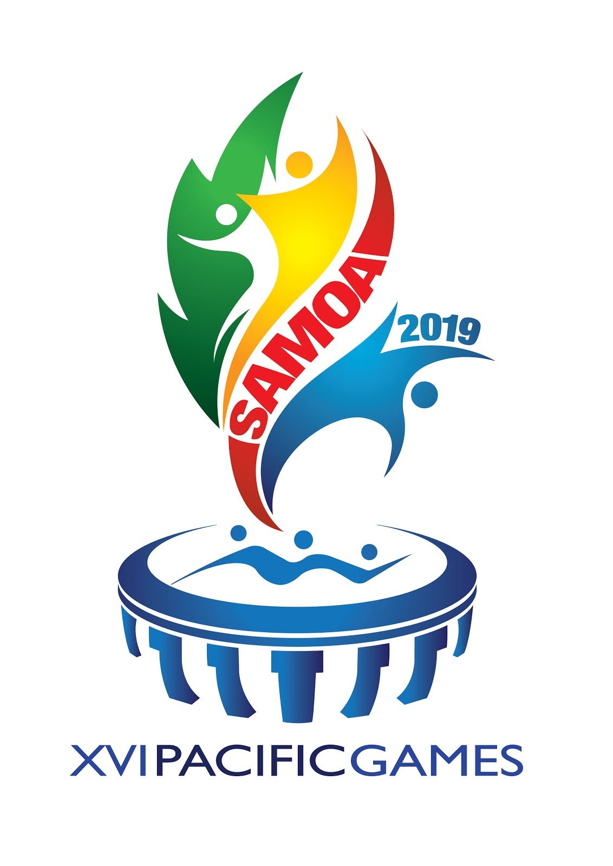
PACIFIC GAMES SQUASH - SAMOA 2019
MEN’S TEAM EVENT
RESULTS
DAY 4 – Thursday 11 July – FINALS

BRONZE MEDAL PLAYOFF – 11.30am

Team |  | SAMOA |  |  |  | Team | TAHITI
Player |  |  | Score | Game Score |  | Player |  | Score | Game Score
1 | Semi OLD |  | 11-6,12-14,11-7,13-11 | 3-2 |  | Laurent LOUDIER |  | 6-11,14-12,7-11,11-13 | 2-3
2 | Jordan CHEWLIT |  | 11-8,11-5,11-9 | 3-0 |  | Nicolas Stuhlfauth |  | 8-11,5-11,9-11 | 0-3
3 | Ivan CHEWLIT |  | 11-7,11-2,11-5 | 3-0 |  | Kamal SOUSSI |  | 7-11,2-11,5-11 | 0-3
4 | Chad RANKIN |  | 11-13,11-6,11-3 | 0-3 |  | Kevin PONS |  | 13-11,11-6,11-3 | 3-0
 | TOTAL GAME SCORE |  |  | 3 |  | TOTAL GAME SCORE |  |  | 1

GOLD MEDAL PLAYOFF – 4.30pm

Team |  | NEW CALEDONIA |  |  |  | Team | PAPUA NEW GUINEA
Player |  |  | Score | Games |  | Player |  | Score | Games
1 | Enzo CORIGLIANO |  | 11-2,11-2,11-1 | 3-0 |  | Madako SUARI |  | 2-11,2-11,1-11 | 0-3
2 | Nicolas MASSENET |  | 11-7,11-0,11-6 | 3-0 |  | Lokes BROOKSBANK |  | 7-11,0-11,6-11 | 0-3
3 | Yann LECRENON |  | 11-6,11-5,11-9 | 3-0 |  | Michael RUCKLINGER |  | 6-11,5-11,9-11 | 0-3
4 | Gael Gosse |  | 11-1,11-2,11-2 | 3-0 |  | Chris WHITCHURCH |  | 1-11,2-11,2-11 | 0-3
 | TOTAL GAME SCORE |  |  | 3 |  | TOTAL GAME SCORE |  |  | 0

FINAL PLACINGS
GOLD MEDAL | SILVER MEDAL | BRONZE MEDAL
NEW CALEDONIA | PAPUA NEW GUINEA | SAMOA

